**Instagram Worst Social Media App for Young People’s Mental Health**

CNN - May 20, 2017

**Instagram**

Instagram is the most detrimental social networking app for young people’s mental health, followed closely by Snapchat, according to a new report by the Royal Society for Public Health (RSPH) in the UK.

Their study, #StatusofMind, surveyed almost 1500 young people aged 14 to 24 on how certain social media platforms impact health and wellbeing issues such as anxiety, depression, self-identity and body image.

YouTube was found to have the most positive impact, while Instagram, Snapchat, Facebook and Twitter all demonstrated negative affects overall on young people’s mental health.

Instagram — the image-saturated app with over 700 million users worldwide — topped the list in terms of negative impact, most notably among young women, stated the report, published Friday.

Instagram draws young women to “compare themselves against unrealistic, largely curated, filtered and Photoshopped versions of reality,” Matt Keracher, author of the report, told CNN.

“Instagram easily makes girls and women feel as if their bodies aren’t good enough as people add filters and edit their pictures in order for them to look ‘perfect,’ ” an anonymous female respondent said in the report.

To tackle the problem, the RSPH has called for social media platforms to take action in order to help combat young users’ feelings of inadequacy and anxiety by placing a warning on images that have been digitally manipulated.

“We’re not asking these platforms to ban Photoshop or filters, but rather to let people know when images have been altered so that users don’t take the images on face value as real,” Keracher said.

“We really want to equip young people with the tools and the knowledge to be able to navigate social media platforms not only in a positive way but in a way that promotes good mental health,” he added.

The survey concluded that while Instagram negatively affected body image, sleep patterns and added to a sense of “FOMO” — the fear of missing out — the image app was also a positive outlet for self-expression and self-identity for many of its young users.

Professional YouTuber Laci Green, a health vlogger with 1.5 million subscribers said that education surrounding mental health issues in a digital age is an educational imperative for young people.

“Because platforms like Instagram and Facebook present highly curated versions of the people we know and the world around us, it is easy for our perspective of reality to become distorted,” she said. “Socializing from behind a screen can also be uniquely isolating, obscuring mental health challenges even more than usual.”

Green added that it is important we lay the groundwork now to minimize potential harm as the first generation of social media users become adults.

YouTube was the only social media platform that demonstrated an overall positive impact on young people’s mental health in the study.

**A health crisis or an educational opportunity?**

The report also found that it’s not just what young people are engaging with on social media, but also how long they are engaging with it.

Young people who spend more than two hours per day connecting on social networking sites are more likely to report poor mental health, including psychological distress, according to the report.

“Platforms that are supposed to help young people connect with each other may actually be fueling a mental health crisis,” Shirley Cramer, chief executive of RSPH noted in the report.

To address this, the RSPH have also recommended the introduction of a pop-up warning to alert users that they have been online for too long.

Seven in ten young people surveyed supported the recommendation, but with experts describing social media use as more addictive than cigarettes and alcohol, it’s not clear whether a “heavy usage” pop-up would be enough to break through that barrier.

Sir Simon Wessely, President of the UK’s Royal College of Psychiatrists supports an education-based approach and warns that demonizing social media is not the answer.

“I am sure that social media plays a role in unhappiness, but it has as many benefits as it does negatives,” he said. “We need to teach children how to cope with all aspects of social media — good and bad — to prepare them for an increasingly digitized world. There is real danger in blaming the medium for the message.”

**Facebook and Twitter 'harm young people's mental health'**

*The Guardian* – Dennis Campbell – May 19, 2017

Poll of 14- to 24-year-olds shows Instagram, Facebook, Snapchat and Twitter increased feelings of inadequacy and anxiety. Young people scored Instagram the worst social medium for sleep, body image and fear of missing out. Photograph: Mark Mawson/Getty Images

Four of the five most popular forms of social media harm young people’s mental health, with [Instagram](https://www.theguardian.com/technology/instagram) the most damaging, according to research by two health organizations.

Instagram has the most [negative impact on young people’s mental wellbeing](https://www.theguardian.com/society/2017/apr/09/social-networks--children-chat-feel-less-happy-facebook-instagram-whatsapp), a survey of almost 1,500 14- to 24-year-olds found, and the health groups accused it of [deepening young people’s feelings of inadequacy and anxiety](https://www.theguardian.com/media/2015/nov/04/instagram-young-women-self-esteem-essena-oneill).

The survey, published on Friday, concluded that Snapchat, [Facebook](https://www.theguardian.com/technology/facebook) and Twitter are also harmful. Among the five only YouTube was judged to have a positive impact.

The four platforms have a negative effect because they can exacerbate children’s and young people’s body image worries, and worsen [bullying](https://www.theguardian.com/commentisfree/2015/sep/16/social-media-mental-health-teenagers-government-pshe-lessons), sleep problems and feelings of anxiety, depression and loneliness, the participants said.

The findings follow growing concern among politicians, health bodies, doctors, charities and parents about young people suffering harm as a result of sexting, cyberbullying and social media reinforcing feelings of self-loathing and even the risk of them committing suicide.

“It’s interesting to see Instagram and Snapchat ranking as the worst for mental health and wellbeing. Both platforms are very image-focused and it appears that they may be driving feelings of inadequacy and anxiety in young people,” said Shirley Cramer, chief executive of the [Royal Society for Public Health](https://www.rsph.org.uk/), which undertook the survey with the [Young Health Movement](http://www.yhm.org.uk/).

She demanded tough measures “to make social media less of a wild west when it comes to young people’s mental health and wellbeing”. Social media firms should bring in a pop-up image to warn young people that they have been using it a lot, while Instagram and similar platforms should alert users when photographs of people have been digitally manipulated, Cramer said.

Advertisement

The 1,479 young people surveyed were asked to rate the impact of the five forms of social media on 14 different criteria of health and wellbeing, including their effect on sleep, anxiety, depression, loneliness, self-identity, bullying, body image and the fear of missing out.

Instagram emerged with the most negative score. It rated badly for seven of the 14 measures, particularly its impact on sleep, body image and fear of missing out – and also for bullying and feelings of anxiety, depression and loneliness. However, young people cited its upsides too, including self-expression, self-identity and emotional support.

[YouTube](https://www.theguardian.com/technology/youtube) scored very badly for its impact on sleep but positively in nine of the 14 categories, notably awareness and understanding of other people’s health experience, self-expression, loneliness, depression and emotional support.

However, the leader of the UK’s psychiatrists said the findings were too simplistic and unfairly blamed social media for the complex reasons why the mental health of so many young people is suffering.

Prof Sir Simon Wessely, president of the Royal College of Psychiatrists, said: “I am sure that social media plays a role in unhappiness, but it has as many benefits as it does negatives.. We need to teach children how to cope with all aspects of social media – good and bad – to prepare them for an increasingly digitised world. There is real danger in blaming the medium for the message.”

Young Minds, the charity which Theresa May visited last week on a campaign stop, backed the call for Instagram and other platforms to [take further steps to protect young users](https://www.theguardian.com/commentisfree/2015/sep/16/social-media-mental-health-teenagers-government-pshe-lessons).

Tom Madders, its director of campaigns and communications, said: “Prompting young people about heavy usage and signposting to support they may need, on a platform that they identify with, could help many young people.”

However, he also urged caution in how content accessed by young people on social media is perceived. “It’s also important to recognise that simply ‘protecting’ young people from particular content types can never be the whole solution. We need to support young people so they understand the risks of how they behave online, and are empowered to make sense of and know how to respond to harmful content that slips through filters.”

Parents and mental health experts fear that platforms such as Instagram can make young users feel worried and inadequate by facilitating hostile comments about their appearance or reminding them that they have not been invited to, for example, a party many of their peers are attending.

May, who has made children’s mental health one of her priorities, highlighted social media’s damaging effects in her “shared society” speech in January, saying: “We know that the use of social media brings additional concerns and challenges. In 2014, just over one in 10 young people said that they had experienced cyberbullying by phone or over the internet.”

In February, Jeremy Hunt, the health secretary, warned social media and technology firms that they could face sanctions, including through legislation, unless they did more [to tackle sexting](https://www.theguardian.com/society/2016/nov/29/jeremy-hunt-proposes-ban-on-sexting-for-under-18s), cyberbullying and the trolling of young users.

**Social media 'more addictive than cigarettes and alcohol'**

The Express Tribune - By [Ahmad Ali](https://tribune.com.pk/author/6814/ahmad-ali/) - May 21, 2017

Social networking websites can be more addictive than cigarettes and alcohol and can have an overall negative effect on young people’s mental health, says a new report.

The study conducted by Royal Society for Public Health in the UK surveyed almost 1,500 young people aged 14 to 24 on how social media platforms can impact health and wellbeing in issues such as anxiety, depression, self-identity and body image.

The research found that 91% of 16-24 year olds use the internet for social networking which has been described as more addictive than cigarettes and alcohol. The increased use of social media may have also led to higher rates of anxiety and depression in young people which have risen by 70% in the past 25 years.

The [*Status of Mind*](https://www.rsph.org.uk/our-work/policy/social-media-and-young-people-s-mental-health-and-wellbeing.html) report found that most social media platforms have an overall negative effect on teenager’s wellbeing with YouTube being the only exception. The video streaming website was found to have the most positive impact, while major social media website such as Instagram, Snapchat, Facebook and Twitter all demonstrated negative effects.

Interestingly, photo sharing app Instagram was found to have worst impact on young people’s mental health.

Instagram draws young women to “compare themselves against unrealistic, largely curated, filtered and Photoshopped versions of reality,” said Matt Keracher, author of the report.

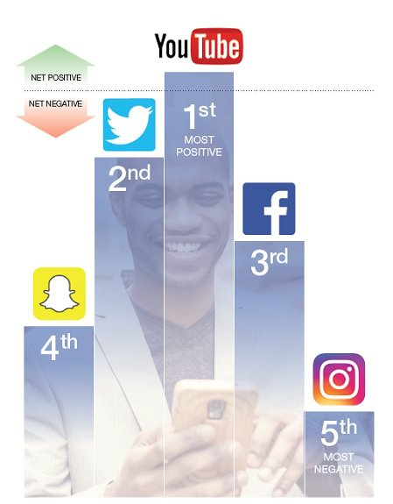

PHOTO: STATUS OF MIND

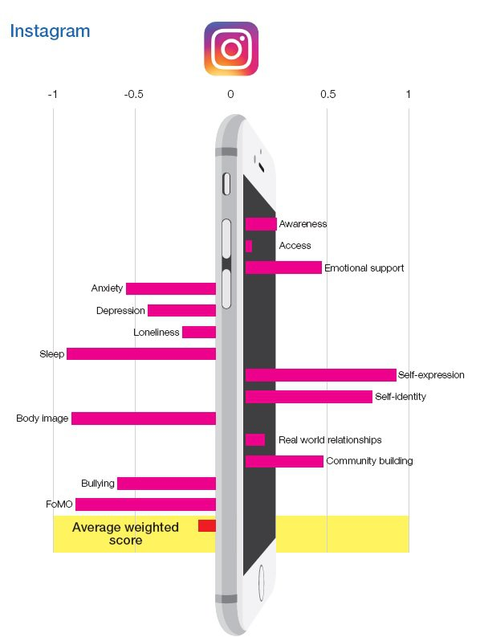

“Instagram easily makes girls and women feel as if their bodies aren’t good enough as people add filters and edit their pictures in order for them to look ‘perfect’,” an anonymous female respondent said in the report.

In addition to this, the research suggests that heavy users of social media who spend more than two hours per day on social networking sites are more likely to report poor mental health. The study finds that unrealistic expectations set by social media may leave young people with feelings of self-consciousness, low self-esteem and the pursuit of perfectionism which can manifest as anxiety disorders.

PHOTO: STATUS OF MIND

Using social media on phones, laptops and tablets at night before bed is also linked with poor quality sleep. The research found that one in five young people said they wake up during the night to check messages on social media, leading them to feel constantly tired at school.

The research also found that 7 in 10 young people experience cyber bullying, with 37% of young people saying they experience cyber bullying on a high-frequency basis. Facebook users were found to be twice as likely to be bullied than on any other social network. Victims of such bullying were found to be more likely to experience low academic performance, depression, anxiety and self-harm.

Researchers at Royal Society for Public Health have also suggested certain steps to curtail some negative effects of excess use of social media sites. These include the introduction of a pop-up heavy usage warning on websites. “A pop-up warning would give young people access to this information so they can make informed decisions about their own health.”

In addition to this, social media platforms are recommended to identify users who could be suffering from mental health problems by their posts and other data, and discreetly signpost to support. “We would like to see technology used to identify those young people who could be suffering from mental health conditions on social media, and provide them with discreet information about where they can find help and advice should they wish to receive it,” the report further states.